**AWS Task-1**

**Task Description:**

Create a windows Vm machine in AWS and connect with RDP open CMD in windows share the about system info.

Explanation:

1. Login to Aws console and navigate to ec2 instance. Click launch instance.

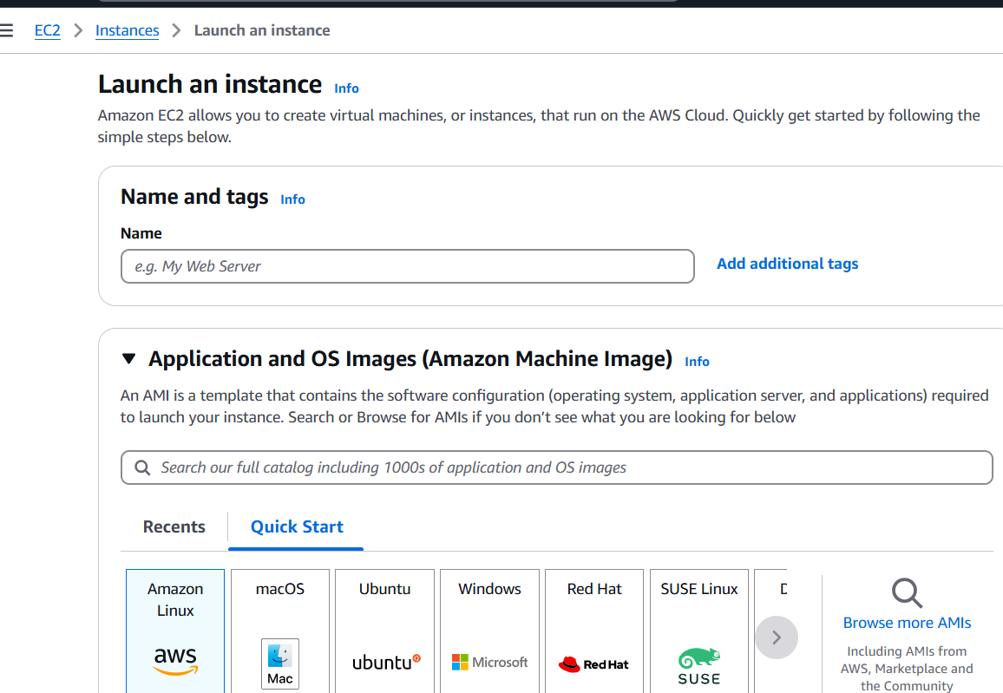

1. Provide the following details

Name : Windows-VM

AMI: Windows

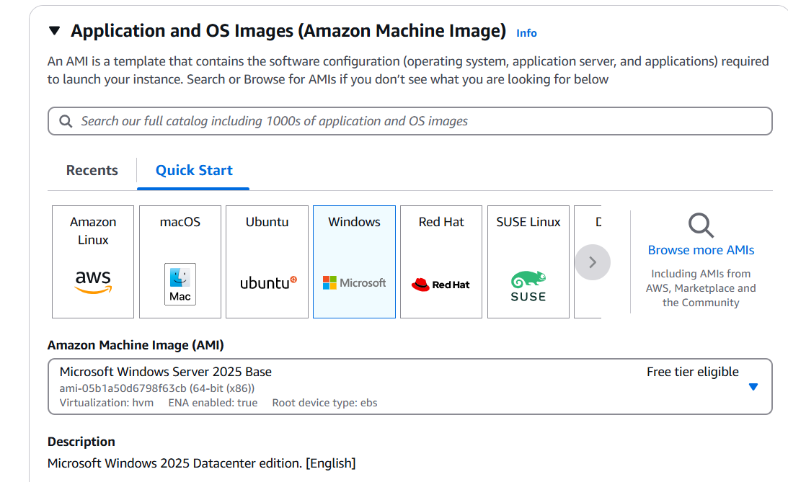

Instance type : t3.micro

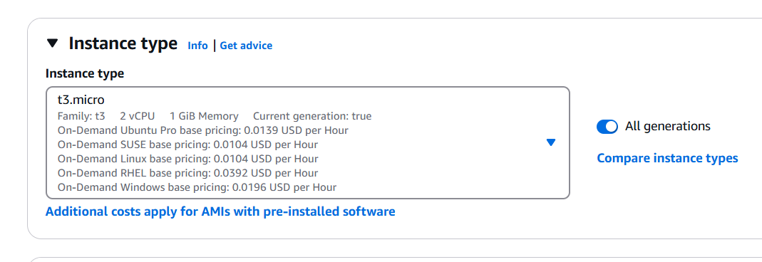

Key pair – create new key pair or use existing one

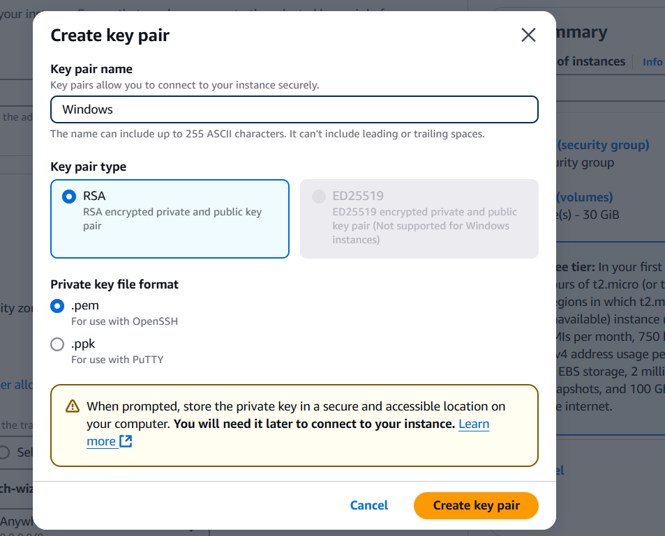

Click launch instance.

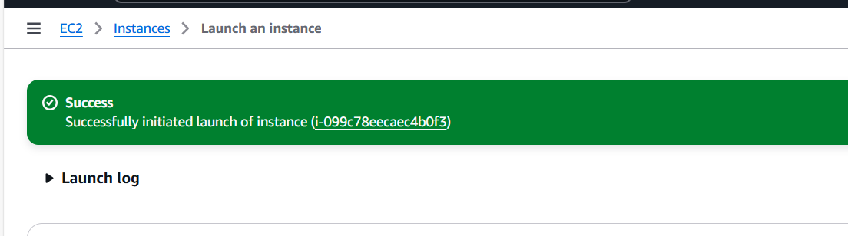

1. Post launching instance, ensure the security group allows RDP (TCP port 3389).

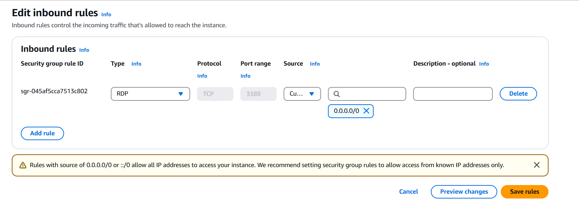

1. To connect to the windows VM via RDP
2. Retrieve admin password by navigating

Ec2 dashboard >> instance >> select the windows instance>>actions>>security>> get windows password

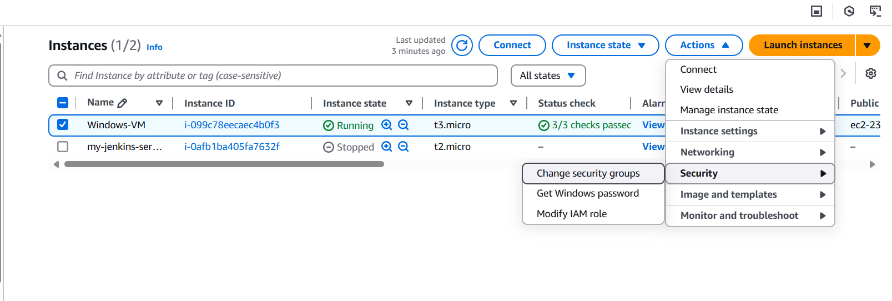

Upload the downloaded pem file and click decrypt password.

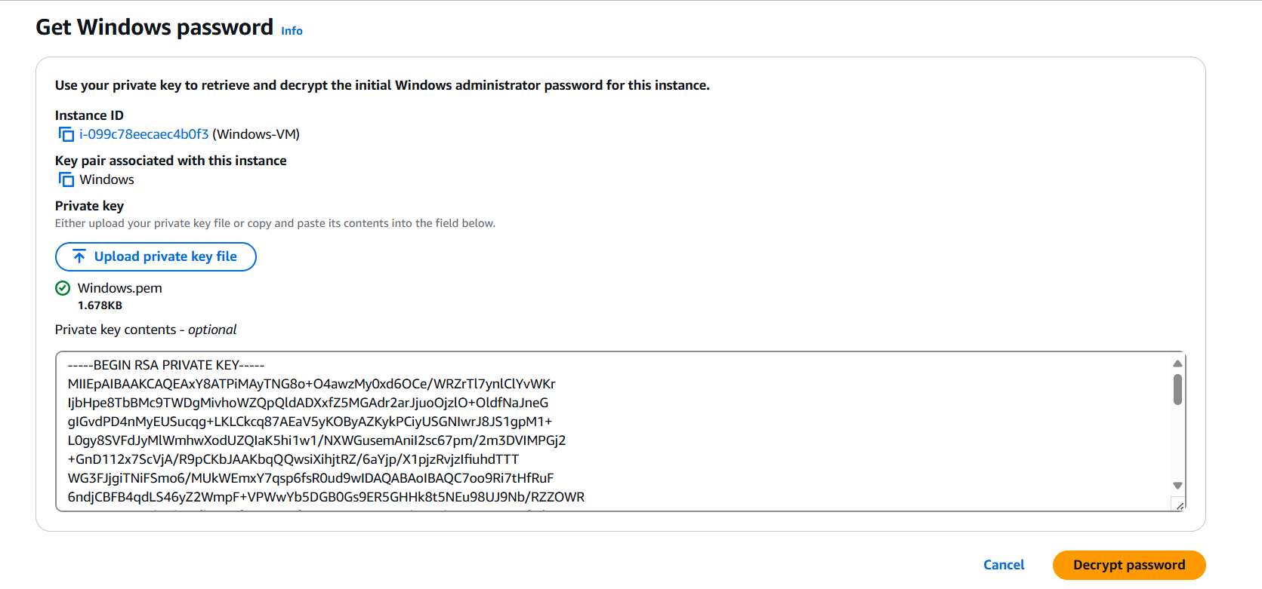

Note the password.

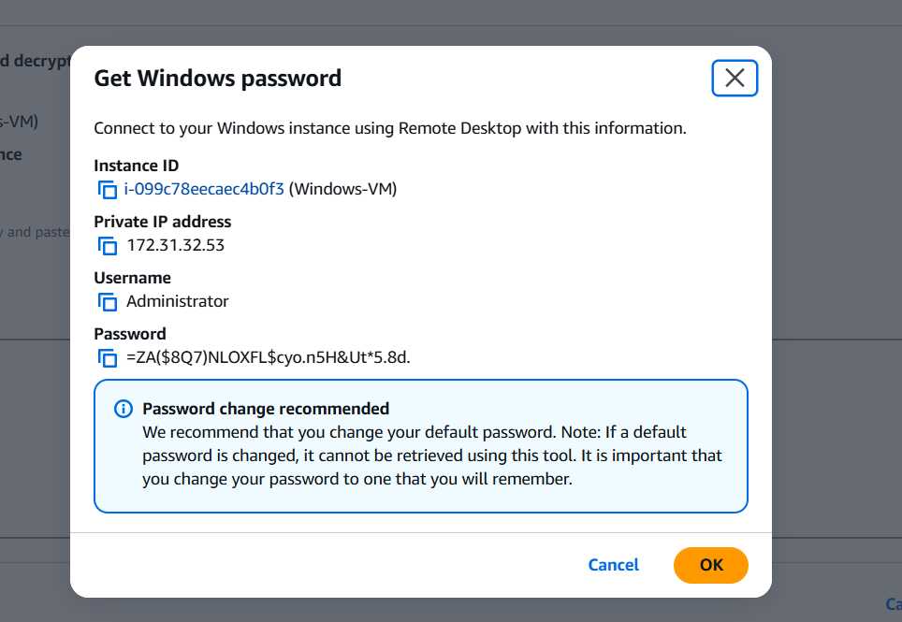

1. To connect using Remote Desktop Protocol (RDP)

Pree win +r, type mstsc

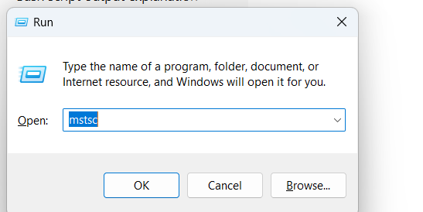

Enter the public ipv4 address and click connect.

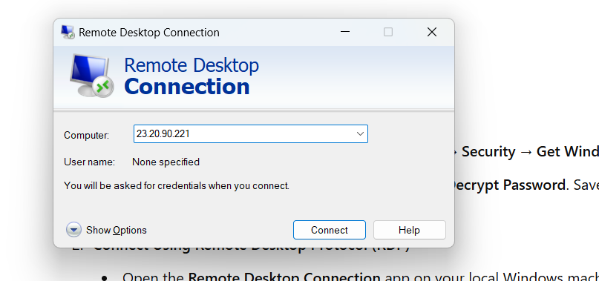

Use the username (Administrator) and the decrypted password to log in. Remote desktop is launched.

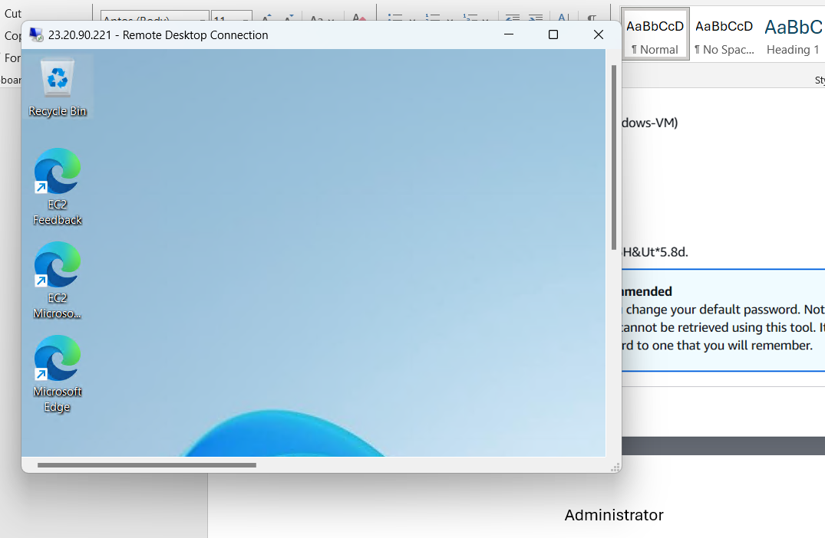

1. Use the cmd, give systeminfo to view the about info

